Title: Trends in oyster populations in the Big Bend region of the northeastern Gulf of Mexico: An assessment of river discharge and fishing effects over time and space.

Authors: TBD

*Intro*

Many species of oysters of the family Ostreidae are globally recognized as a critical estuarine component where they provide important ecosystem and fishery benefits (Gutiérrez et al. 2003; Coen et al. 2007; Carranza et al. 2009; Grabowski 2012). Large declines in oyster populations have been observed at global (Beck et al. 2011), continental (Zu Ermgassen et al. 2012; Alleway and Connell 2015), regional (Seavey et al. 2011; Wilberg 2011), and local spatial scales (Pine et al. 2015; Grizzle et al. 2018). These losses have been widely documented including localized extirpations in Australia (Alleway and Connell 2015) and large biomass reductions in the US particularly in the Chesapeake Bay and US Gulf of Mexico regions where eastern oyster *Crassostrea virginica* are highly valued from cultural, fishery, and ecosystem service perspectives. The US Gulf of Mexico region alone likely supports the world’s largest remaining natural oyster reefs (Beck et al. 2011), and these reefs provide about 69% of the US commercial wild eastern oyster harvest (2016 data, see https://tinyurl.com/y4yhnre3). Florida has historically supported about 10% of this total, but following the collapse of the Apalachicola Bay oyster fishery in 2012 (Pine et al. 2015) this total has declined to about 5% of total landings (NOAA 2016).

Here, we assess recent trends in intertidal eastern oyster populations (“oyster” hereafter) in the Suwannee River estuary, an area of high conservation value in the “Big Bend” region of the northeastern Gulf of Mexico, using fisheries independent data from irregular monitoring efforts. The Suwannee River estuary is one of the least developed coastal regions in the continental US as more than 30% of the land area and about 100 km of coastline is protected (Main and Allen 2007) and road and human population densities are among the lowest in Florida (Geselbrach 2007; Southwick Associates 2015). Loss of oyster reefs in this area is of conservation concern (Beck et al. 2000) as oyster reefs have large ecological and economic value. In this region, about 13% of private sector employment and 25% of all economic activity is related to natural resources (Southwick Associates 2015) including commercial shellfish harvest. Oyster reefs can form both intertidal and subtidal reefs, and the Big Bend is known for expansive intertidal reefs that have important ecological and hydrological roles in the region. Kaplan et al. (2016) suggested that intertidal oyster reefs in the Big Bend provide a keystone ecosystem service due to their physical orientation as linear chains parallel to the coastline. Because of this orientation, these reefs help to promote detention of freshwater and modulation of salinity to promote estuarine conditions. Bergquist et al. (2006) and Seavey et al. (2011) identified decadal changes in intertidal oyster reefs in this region with Seavey et al. (2011) documenting a 66% net loss in oyster area from 1982-2011, with offshore intertidal reefs experiencing an 88% loss, nearshore reefs 61% loss, and inshore reefs 50% loss from aerial imagery assessments. Reasons for intertidal oyster population decline in this area are unknown, but Seavey et al. (2011) proposed a relationship with changes in freshwater discharge from the Suwannee River leading to cascading changes in frequency of mortality events, loss of nucleation sites for oyster spat, and an irreversible collapse of an intact oyster reef. Small-scale tests of restoring intertidal oyster reefs through construction of nucleation sites have suggested that nucleation sites are indeed limiting this population (Frederick et al. 2016, Kaplan et al. 2016) and larger restoration efforts are now underway (Pine et al. in-review).

*Methods*

*Description of study area*

The Suwannee River estuary in the northeastern Gulf of Mexico (Figure 1) can be divided into three subareas (Orlando et al. 1993), including the lower Suwannee River, upper Suwannee Sound, and lower Suwannee Sound. These shallow (<2-m) regions, fringed by coastal marsh, shell/sand and oyster bars, are bisected by the Suwannee River and generally bounded to the north by Horseshoe Point and south by Cedar Keys (Orlando et al. 1993; Wright et al. 2005). State and federal partners manage most of the land surrounding the estuary and the 54-km tidally influenced reach of the Suwannee River as conservation land. Suwanee Sound is an open ocean-facing deltaic estuary (Orlando et al. 1993; Wright et al. 2005) and is heavily influenced by discharge from the Suwannee River which provides about 60% of the inflow to the entire Florida Big Bend region (Montague and Odum 1997). Suwannee Sound is the largest estuary within the Big Bend region. The Suwannee River is undammed and free-flowing (Benke 1990), but river discharge may be modified due to surface and sub-surface water withdrawals within the basin (Mattson 2002). Water inputs are from extensive groundwater inflows from the Floridan aquifer and surface water runoff from precipitation. Suwannee River discharge is a major factor influencing monthly, seasonal, and annual variation in salinity in Suwannee Sound (Orlando 1993; Mattson 2002).

Whereas in most river basins river discharge-per-unit-rainfall has increased in recent decades due to watershed changes such as conversion from forest to agriculture or increase in impervious surfaces, in the Suwannee River the opposite trend has been observed where river discharge has actually declined-per-unit-rainfall possibly due to increasing human use of surface and groundwater (Seavey et al. 2011). Resulting decreased groundwater levels can impact human users in this region such as the collapse of the drinking water supply system in the town of Cedar Key during the drought in 2012 (Saetta et al. 2015), but ecosystem impacts are unknown. Climate reconstructions from dendrochronological records for this region suggest a much wider range of precipitation patterns in past centuries than has been observed in recent decades (Harley et al. 2017).

*Data Collection – Line Transects*

We selected four localities for sampling (Figure 1) with three in Suwannee Sound (Horseshoe Beach [Cove], Lone Cabbage, and Cedar Keys) and Corrigan’s Reef east of the town of Cedar Key. At each locality, we designated linear groups of oyster reefs as Inshore, Nearshore, or Offshore sites based on their orientation and relative distance from shore. We then randomly chose individual oyster reefs within each of these sites for sampling (generally 3 unique small reefs within each site and locality). At each of these sampling stations, we then established fixed locations on each oyster reef to conduct line transect sampling to estimate oyster counts and density. Oyster reefs were sampled when tidal heights were less than -0.84 m NAVD 88 as measured at NOAA tidal station 8728520. At this tidal height, intertidal oyster reefs in this area will dewater, facilitating visual counts of oysters with line transect surveys. Transect width was 15.24 cm and transect length was the width of the oyster reef at the tidal height of sampling, with the bar oriented parallel to the coast. The starting point for the transect on the bar was randomly chosen in GIS. Steel rebar posts (0.5-m) were used to mark transect locations for repeat visits, and GPS coordinates recorded using a handheld GPS device. Live and dead oysters were then counted visually along each transect and recorded in 2.5-m intervals.

*Data Analyses – Generalized Linear Models*

We used generalized linear models (GLM, Bolker et al. 2008) to assess oyster counts (dependent variable) over period (time variable, a winter or summer period of time each year), locality (i.e., Horseshoe, Lone Cabbage etc.), and Site (Inshore, Nearshore, Offshore) We assumed that oyster counts were likely to increase with transect length so we included transect length as an offset of effort (log link function) which allowed the response variable to remain an integer. To assess the distribution of these data we assumed that count data are discrete, and examined the ratio between the variance of the counts and the mean count per site, and graphical representations of predicted vs. observed distributions of count data from each site. We used the best fitting (lowest AIC) model to predict oyster counts by period. All models were fit using the glmmTMB package (Brooks et al. 2017) in R (R Core Team 2018).

We also developed a candidate set of models of biological interest to fit to these data. As an estuarine species, the role of salinity in influencing oyster recruitment and survival is of interest to resource managers (Turner 2006; Buzan et al. 2009; Fisch and Pine 2016). Oyster population status has been considered a metric for estuarine ecosystem health (Berquist et al. 2006; Coen et al. 2007) and to evaluate minimum flow regulations in the Suwannee River basin (Farrell et al. 2005; Berquist et al. 2006). We conducted exploratory analyses of how Suwannee River discharge (USGS gauge 02323500), as a proxy for salinity, nutrient inputs, and other factors, influenced counts on oyster reefs. We assessed how river discharge in year of sampling and a 1 and 2-year lag of river discharge influenced oyster counts. All continuous covariates were centered (mean = 0, standard deviation = 1) using the scale function in R before including in each GLM model.

Similarly, we assessed whether oyster harvest affected oyster counts by examining whether an area was open or closed to oyster harvest as a factor and whether oyster landings, trips or catch-per-unit-effort for the given year or with a 1 or 2-year lag prior influenced oyster counts. The relationship between our response variable, oyster counts on intertidal oyster bars, and oyster harvest is complicated. Oysters that grow on intertidal oyster reefs are generally smaller (below minimum legal harvest size limit of 75.2-mm) than subtidal oysters and therefore are not traditionally targeted for harvest. However, these intertidal bars are adjacent to subtidal bars, which are harvested, and we have observed oyster harvest and culling on intertidal bars particularly in years with high oyster demand (W.E. Pine, *personal observation*). Oyster harvest in prior years may influence oyster counts because oyster harvest removes, disturbs, and fragments shell on oyster reefs. Oyster shell is the dominant substrate on which larval oyster spat settle and recruit, thus harvest could reduce recruitment due to loss of settlement substrate (Powell and Klinck 2007; Pine et al. 2015) and modification of vertical structure. We used a forward selection process where we fit each parameter individually and then retained statistically significant factors (p<0.05). Final model comparison was then made with AIC when appropriate.

*Simulations*

To assess the “informativeness” of our GLM modelling approach (as a type of power analyses, Bolker 2008), we generated 500 replicate datasets (with replacement) of oyster counts by locality, site, and period and fixed transect length to the transect length used at each oyster reef in the original data. To simplify simulations, we did not simulate data for the covariates of river discharge or fishery landings. We then fit the best fitting (lowest AIC) model without covariates to these data and assessed (1) how many of these 500 simulations had the same negative beta coefficient for period (indicating a decline in oyster counts over time) and (2) the distribution of p-values for the period beta coefficient. This was done to assess how likely we were to detect both the sign and the significance of a change in oyster counts over period (time) if one were to occur.

*River discharge*

Because salinity in Suwannee Sound is influenced by Suwannee River discharge, and oyster populations are an estuarine dependent species, we summarized river discharge data using the Suwannee River USGS gauge 02323500 near Wilcox, Florida. We used the longest continuous data records beginning October 1941-July 2019 to show long-term trends and summarized river discharge (by convention as Cubic feet Second) for each year as mean daily, the variance of daily discharge, CV of daily discharge, and total annual discharge. We also calculated these same metrics for the overall time series. We included a locally weighted scatterplot smoothing (LOWESS) line to aid in visually assessing trends in Suwannee River discharge metrics. We assessed how river discharge in year of sampling as well as a 1- or 2-year lag of river discharge influenced oyster counts.

*Commercial fishing and landings*

We categorized each site as either open or closed to commercial fishing based on harvest zones available from the Florida Department of Agriculture and Consumer Services (https://tinyurl.com/y3tnqlpq). We included fishing as a factor in our GLM analyses to assess whether or not being in a region open to fishing influenced oyster counts. To examine long-term trends in oyster landings and fishing effort, we obtained annual oyster landings data (oyster meat weight and oyster fishing trips) for the three counties in the Suwannee Sound region (Taylor, Dixie, Levy) from the Florida Fish and Wildlife Conservation Commission (see https://tinyurl.com/yxdd8qhc) beginning in 1986-2018. While landings data for oysters are available prior to 1986, the mandatory trip ticket reporting program was not officially implemented until 1986. We included the current year and a 1- or 2-year lag of oyster landings and oyster fishing trips in our GLM analyses to assess whether oyster fishing effort in prior years influenced oyster counts.

*Results*

*Evaluating distribution of data*

Based on (1) our use of count data, (2) variance of oyster counts exceeding the mean, (3) high dispersion, and (4) visual assessment of observed oyster counts vs. predicted counts based on a negative binomial distribution (Figure 2), we concluded a negative binomial distribution to be a reasonable fit to the observed data and used this distribution for each GLM model.

*GLM analyses*

The top GLM models (lowest AIC) included a combination of period, site, and locality as additive or interaction terms, and these models were very similar in AIC value (Table 1; delta AIC = 1.68 across top three models). The top model (period*site+locality+ offset(log(transect length))) allowed for a unique slope by period and site. We found oyster counts to differ across period of time (p=0.000676, Table 2, Figure 3) and we found that nearshore sites differed from inshore sites (p=9.25e-16, Table 2, Figure 3). We found a locality effect only for Corrigan’s Reef (p=0.015817, Table 2). Season of sampling was not a significant factor. Adding covariates of biological and management interest to this model improved fit (Table 3), and best fit was found with a one-year lag on either total annual discharge or mean daily discharge (delta AIC = 0.04 between top two models). A simple ANOVA between the top model with and without a river discharge covariate was significant (p= 1.909 e-11). Including annual discharge in the model again led to significant period and site effects, with Corrigan’s Reef the only locality effect while annual discharge was highly significant (p = 4.06e-11; Table 3). Including landings, trips, or open/closed harvest status as a category was not an improvement over including river discharge.

*Trends in Suwannee River discharge*

We found generally declining trends in mean daily discharge, stable trends in daily discharge variance, increasing trends in the CV of daily discharge (a measure of volatility) and declines in total annual discharge by year since October of 1941 (Figures 4 and 5). Since 2010, mean daily discharge and total annual discharge has been below the 1941-2018 average in six of the last nine years, near average for two years, and above average for one year (Figure 5).

*Commercial fishing and landings*

During 2010-2019 commercial oyster landings, trips, and catch-per-trip were variable with a large increase in landings and trips in 2016, and then decline in 2017 (Figures 6 and 7). This increase in landings and trips equaled the third highest values for the 1986-2019 time period (Figure 6). Catch-per-trip has generally trended down since 2010 (Figure 7).

*Simulation to check performance of models*

From our simple simulations, we found that our best fit model without covariates (period*site+locality+ offset(log(transect length)) was informative both in terms of the direction (Figure S1) and significance (Figure S2) of the beta terms. Of our 500 simulated data sets, all (100%) had a negative beta parameter for period indicating a decline in oyster counts. We also found that the distribution of p-values was generally centered around 0.01 (Figure S2), which was higher than the p-value estimated for the original data (p=0.0007). Of the 500 simulations, 470 p-values were less than alpha = 0.05 (94%). These results suggest our model is informative and reliable in detecting change in oyster counts over time.

*Discussion*

We document declines in intertidal oyster reefs in a region of the US Gulf of Mexico that has low human population density, large areas of protected lands, and relatively low oyster harvest – all factors that potentially suggest high likelihood of viable oyster populations compared to other regions within eastern oyster native range. Declines in oyster populations and the loss of associated ecosystem services and fishery resources in this region is therefore of significant conservation concern. Causal factors for oyster population declines are often not clear owing to complex interactions between fishery harvests (Wilberg et al. 2011), oyster habitat (Wilberg et al. 2013; Pine et al. 2015), changes in water quality and quantity (Seavey et al. 2011; Pine and Fisch 2016), disease dynamics (Powell et al. 1992), and other unknowns. These and other factors are generally influenced in multiple and uncertain directions by changing climate (Mulholland et al. 1997; Gazeau 2007; Miller et al. 2009).

In our assessment, we found a relationship between mean daily discharge or annual total river discharge one year prior, and intertidal oyster population counts (Table 4, Figure 8). The reported relationships between river discharge and oyster population responses are various, complicated, and unclear, from an ecological, management, and legal perspective (La Peyre et al. 2009; Buzan et al. 2009; Fisch and Pine 2016, SCOTUS 2018). As an estuarine dependent species, oysters should be subjected to unfavorable conditions in years where estuarine conditions are not suitable due to flood, drought, or other factors influencing river discharge, leading to poor recruitment or survival. These same conditions may also influence the likelihood of mortality from disease (La Peyre et al. 2003) or marine predators and parasites (Kimbro et al. 2017; Pusack et al. 2019), which may reinforce negative effects.

While we found a positive relationship between mean daily discharge or annual total Suwannee River discharge and intertidal oyster counts one year later, this does not mean that higher river discharge universally leads to more oysters. During 2010-2019 we observed years with much lower average Suwannee River discharge, and infrequent years of high discharge. Because of this (restricted range of discharge during our period of oyster count collection), the relationship between higher average discharge and oyster counts is less clear. Figure 8 must be carefully considered as it may be misleading as there are many factors in addition to river discharge that may be limiting factors for oyster populations. Indeed, higher river discharge levels can lead to lower salinity and lower spat production (Chatry et al. 1983) for many of the same reasons that high salinity can be deleterious (Pusack et al. 2019). Thus, the relationship between river discharge and oyster counts that we report may not be representative of the upper end of the discharge range, an important consideration for a subset of possible climate change scenarios.

This paper demonstrates a relationship between river discharge and oyster counts, but freshwater inputs are just one of several factors likely necessary for resilient oyster populations. A key limiting factor for oyster spat distribution in Suwannee Sound is the availability of suitable substrate for oyster spat settlement and growth (Frederick et al. 2015). Frederick et al. (2015) demonstrated in a small pilot project that the placement of limestone boulders on a section of the degraded Lone Cabbage oyster reef led to increased oyster spat and oyster recruitment on the reef site. This demonstrates the necessity of having suitable substrate for oyster spat settlement and reef growth which is at present being tested on a larger scale (Pine et al. in-review) and may be important in other Florida estuaries (Pine et al. 2015). Overall, the limiting factors for oyster reef creation, persistence, collapse, restoration, and recovery remain unclear.

Oyster disease, parasites, and predators have existed in this (and other) systems for much longer than the 60+ years of river discharge records available for the Suwannee River. Climatological assessments over the scale of centuries suggest that the Suwannee River basin overall has experienced periods of much drier conditions (Harley et al. 2017) particularly during the 16th and 18th centuries, with river discharge likely less than 20% of the mean estimated from the instrument period of record - yet oyster populations did not go extinct in this region. Oyster reefs in and around Lone Cabbage reef have persisted for 2800-4000 years (Grinnel 1974; Wright et al. 2005) including time with extensive human occupation and oyster harvest (Sassaman et al. 2017). One key concern is that while oyster populations may have recovered historically from episodic mortality due to drought, disease, or other factors, this resilience may have declined. If resilience has declined in oyster reefs, and disturbance continues to occur, these conditions may foment an increased risk of hysteresis where multiple “states” of oyster populations may exist across similar environmental conditions. Modeling efforts by Pine et al. (2015) suggest that in absence of suitable substrate for settlement and growth, even with “average” recruitment levels Apalachicola Bay oyster populations were not predicted to reverse declining population trends. Given the recent, rapid collapse of oyster populations across many Gulf of Mexico estuaries, this possibility is of central ecological and management concern.

Our assessment of trends in Suwannee River discharge metrics over the instrument period of record suggests increasing volatility in river discharge (CV) and an overall downward trend in river discharge. The reasons for these trends are unknown, but an examination of trends in the Palmer Drought Severity Index for the southeast Georgia and north Florida regions covering the Suwannee River basin suggest rainfall drought has occurred several times in this region since 2010 (Figure S3a). There is also evidence that the discharge/rainfall ratio has been declining (Seavey et al. 2011) or that evapotranspiration is increasing (or both) possibly influencing temporal trends in discharge. The relationship between frequency and severity of drought and oyster reef resilience is an important area of future research.

We are unable to determine an age-structure for oyster populations so we do not know if oyster counts represent multiple oyster year-classes or not. This is important because it would help to determine whether lower counts are a function of year-class failure in the year of low river discharge, or if multiple year-classes were affected. Other than the irregular monitoring effort we report here, fishery independent data for oyster populations in Suwannee Sound are absent. Since we only sampled intertidal reefs, we do not know if these dynamics extend to inter and sub-tidal oysters of multiple age classes and sizes. Our only other line of inference for population trends over this time are from landings data. These data suggest overall declines in landings and catch-per-effort in the years following the implementation of the trip ticket program in 1986. Over the same time period as these monitoring efforts, oyster landings and effort have increased, and catch per unit of effort has generally declined. Our assessment of whether an intertidal reef was located in an area open or closed to fishing influenced count, or if annual landings or effort influenced count, was not significant. This may suggest that fishing plays less of a role in these intertidal oyster bars than climate related factors such as river discharge. This is a complicated result because while intertidal oysters are generally below the minimum legal harvest size we have increasingly observed harvest activities on intertidal bars. In some years “relay” programs of relocating oysters from intertidal to subtidal areas are used as an approach to increase oysters available for harvest (by relocating oysters to areas where growth is faster and harvest is legal). We hypothesized that a possible relationship could occur due to observed directed harvest of intertidal oysters as well as the potential for complex source-sink (i.e., larval distribution) dynamics between intertidal and subtidal bars that may form a relationship between the two. The effects of fishing on oyster populations in terms of changes in recruitment, settlement substrate, and source-sink dynamics are an area requiring substantial future work.

Seavey et al. (2011) documented large declines of about a 66% net loss in oyster reef area in the Suwannee Sound region from 1982-2011. This work documented highest declines in offshore reefs with about an 88% decline, followed by nearshore reefs (-61%), and inshore (-50%). Our oyster density results also show losses with the largest occurring in inshore areas, which we believe are becoming more similar to offshore and nearshore regions (Figure 3). What is not known is whether these inshore losses are offset by formation of new reefs elsewhere. Seavey et al. (2011) reported inland colonization of salt marsh by oysters in inshore areas, but those increases did not offset net losses experienced in nearshore and offshore reefs. Successional habitat processes have been observed in this region with the conversion of coastal forest to marsh as well as loss of coastal forest communities (Geselbracht et al. 2011; Raabe and Stumpf 2016). At longer time scales, oyster reef distribution along the west coast of Florida has been shown to be quite dynamic in time and space, with Locker et al. (2016) documenting fossilized oyster communities in what is now 116-135 m of water along the central west-Florida shelf Hine et al. (1988) described the complex interactions between geology, currents, and the formation and persistence of oyster reefs along the west coast of Florida, and suggested that seaward oyster reefs are the ones most susceptible to degradation due to higher salinity levels, marine predators, and wave action. These predictions were supported by Wright et al (2005) who identified that most of the oyster bars in Suwannee Sound developed from deltaic sediment deposits . Seavey et al. (2011) showed that once an oyster reef degrades to the point of losing the covering of shell, the likelihood of that reef reforming and persisting is very low. This scenario was reinforced by the findings of Frederick et al. (2015) who showed experimentally that addition of limestone substrate to the degraded Lone Cabbage reef resulted in a rapid and substantial recruitment of oysters.

*Implications*

Our findings suggest that landscape level factors including trends in river discharge likely influence intertidal oyster populations, but the mechanistic reasons are not known. From a freshwater management perspective, river basin level planning efforts in terms of minimum flows and levels are in place or underway to inform water management decisions within the Suwannee River basin (<http://www.srwmd.state.fl.us/114/Suwannee-River>). Long-term forecasts of water demands in areas near the Suwannee Basin and across north Florida and southeast Georgia suggest increased demand and lower ground water levels (see <https://northfloridawater.com/>). In both cases the time horizons for decision making and implementation of large-scale water infrastructure projects is likely longer than the time scale (<10 years) documented here of oyster population change in Suwannee Sound. At shorter monthly or annual time scales, there is potential for expanded restoration actions that would possibly both increase oyster populations by providing substrate, and at the same time reduce loss of freshwater through coastal impoundment ((Frederick et al.2016,Pine et al. in-review). However, these restoration programs are expensive (>$1m/km for Suwannee Sound), and seem unlikely at least at the scale of scale of restoration needed to restore estimated losses of oyster habitat. At century time scales, sea-level rise may negate many short-term benefits of reef restoration because reefs may become inundated with higher salinity water. Observed sea-level rise in this region based on a 100-year record is on average about 2.13 mm/yr (95% CI 1.95-2.31 mm/year; Figure S3c) but the observed rate in recent years is higher (Figure S3c). Simply put, restoration efforts could be swamped by rising sea-level regardless of river discharge conditions.

There are at least two options going forward from a management perspective, but neither is a clear choice as to which is “best” in terms of long-term viability of oyster reefs in Suwannee Sound. One option is to evaluate ongoing restoration efforts (Pine et al. in-review) and if these are successful, work to implement similar programs at larger spatial scales to replace substrate and ecosystem function that is being lost with declining oyster reefs. The second is to assess whether this landscape is simply undergoing a successional process as has happened in the past. This succession could involve the migration of oyster reefs following change in sea levels, as they have occurred previously (Locker et al. 2016; Sassaman et al. 2017) – perhaps now at a faster rate and with people recording the nearly real-time observations. Given large areas of undeveloped public land and low shoreline gradient in this region, the potential certainly exists for migration of oyster habitat into what is at present inland areas. However, this migration would occur at the cost of these inland habitats – which may be inevitable under several sea-level scenarios (Geselbracht et al. 2011). These types of decisions, to implement restoration for short-term gain to delay long-term losses due to sea-level rise, are among the most complicated management decisions to be addressed in both the natural and built environments in upcoming decades. Whether decisions are made, and actions taken before irreversible losses of oyster resources occurs in Suwannee Sound remains unknown.

*Acknowledgements*

We acknowledge the assistance of Jerry Beckham and Laura Adams for sharing their knowledge of oyster fisheries and ecology in this region. We are appreciative for assistance with sampling by a large group of dedicated volunteers. Funding for this manuscript was provided by National Fish and Wildlife Foundation to P. Frederick, W. Pine and L. Sturmer. This is paper 1 in the Lone Cabbage Reef Restoration series.

Table 1. Model selection table for GLM models without covariates.

|  |  |  |  |  |
| --- | --- | --- | --- | --- |
| Model | Number of parameters | AIC | Delta AIC | AIC Weight |
| Period * site + locality | 10 | 3154.92 | 0.00 | 0.50 |
| Period * locality + site | 11 | 3156.40 | 1.47 | 0.24 |
| Period + locality + site | 8 | 3156.61 | 1.68 | 0.22 |
| Period + locality * site | 14 | 3160.46 | 5.54 | 0.03 |
| Period + site | 5 | 3163.71 | 8.79 | 0.01 |
| Period * site | 7 | 3163.72 | 8.80 | 0.01 |
| Period * locality * site | 25 | 3172.31 | 17.38 | 0.00 |
| Period + locality | 6 | 3310.80 | 155.88 | 0.00 |
| Period * locality | 9 | 3316.52 | 161.60 | 0.00 |
| Period | 3 | 3318.29 | 163.37 | 0.00 |

Table 2. Model results for the best fitting GLM model without covariates (Table 1) where oyster counts = period * site + locality + offset(log(transect length)). Parameter estimates are on log scale.

|  |  |  |  |  |
| --- | --- | --- | --- | --- |
|  | Estimate | Std. Error | z value | Pr(>|z|) |
| Intercept | 4.60458 | 0.17666 | 26.065 | < 2e-16 |
| Period | -0.04669 | 0.01374 | -3.399 | 0.000676 |
| Nearshore site | -1.61120 | 0.20049 | -8.036 | 9.25e-16 |
| Offshore site | -2.40687 | 0.21532 | -11.178 | < 2e-16 |
| Corrigan’s Reef | 0.43079 | 0.17852 | 2.413 | 0.015817 |
| Horseshoe Beach | -0.02953 | 0.18247 | -0.162 | 0.871425 |
| Lone Cabbage | -0.10235 | 0.16803 | -0.609 | 0.542459 |
| Period: site Nearshore | 0.02251 | 0.02283 | 0.986 | 0.324294 |
| Period: site Offshore | 0.05412 | 0.02262 | 2.393 | 0.016713 |

Table 3. Model selection table assessing improvements in the fit of best fit model from Table 1 (oyster counts = period * site + locality + offset(log(transect length))) with the addition of covariate described.

|  |  |  |  |  |
| --- | --- | --- | --- | --- |
| Covariate description | Number of parameters | AIC | Delta AIC | AIC Weight |
| Mean annual daily discharge with 1-year lag prior to count | 11 | 3111.86 | 0.00 | 0.51 |
| Total annual discharge with 1-year lag prior to count | 11 | 3111.90 | 0.04 | 0.49 |
| Annual landings with 2-year lag prior to count | 11 | 3138.39 | 26.53 | 0.00 |
| Annual trips with 2-year lag prior to count | 11 | 3138.64 | 26.78 | 0.00 |
| Annual discharge year of count | 11 | 3144.38 | 32.52 | 0.00 |
| Annual landings year of count | 11 | 3147.66 | 35.80 | 0.00 |
| Total discharge year of count | 11 | 3149.74 | 37.88 | 0.00 |
| Annual trips with one-year lag prior to count | 11 | 3150.99 | 39.13 | 0.00 |
| Harvest in year of count | 11 | 3154.27 | 42.41 | 0.00 |
| Landings with one year lag prior to count | 11 | 3155.57 | 43.71 | 0.00 |
| Total trips in year of count | 11 | 3156.14 | 44.28 | 0.00 |
| Annual discharge with two-year lag prior to count | 11 | 3156.40 | 44.54 | 0.00 |
| Annual total discharge with two year lag prior to count | 11 | 3156.44 | 44.57 | 0.00 |

Table 4. Model results for the best fitting GLM model (Table 3) where oyster counts = period * site + locality + annual discharge with 1 year lag + offset(log(transect length)). Parameter estimates are on log scale.

|  |  |  |  |  |
| --- | --- | --- | --- | --- |
|  | Estimate | Std. Error | z value | Pr(>|z|) |
| Intercept | 4.79684 | 0.15903 | 30.163 | < 2e-16 |
| Period | -0.05847 | 0.01138 | -5.137 | 2.79e-07 |
| Nearshore site | -1.63292 | 0.18054 | -9.044 | < 2e-16 |
| Offshore site | -2.36720 | 0.19730 | -11.998 | < 2e-16 |
| Corrigan’s Reef | 0.35860 | 0.16732 | 2.143 | 0.0321 |
| Horseshoe Beach | -0.18998 | 0.17244 | -1.102 | 0.2706 |
| Lone Cabbage | -0.24087 | 0.15988 | -1.507 | 0.1319 |
| Annual river discharge with one year lag prior to count | 0.37620 | 0.05699 | 6.602 | 4.06e-11 |
| Period: site Nearshore | 0.01920 | 0.01976 | 0.971 | 0.3314 |
| Period: site Offshore | 0.04041 | 0.02063 | 1.959 | 0.0501 |

*References*

Bolker, B.M., 2008. *Ecological models and data in R*. Princeton University Press.

Brooks, M.E., Kristensen, K., van Benthem, K.J., Magnusson, A., Berg, C.W., Nielsen, A., Skaug, H.J., Machler, M. and Bolker, B.M., 2017. glmmTMB balances speed and flexibility among packages for zero-inflated generalized linear mixed modeling. *The R journal*, *9*(2), pp.378-400.

Buzan, D., Lee, W., Culbertson, J., Kuhn, N. and Robinson, L., 2009. Positive relationship between freshwater inflow and oyster abundance in Galveston Bay, Texas. *Estuaries and Coasts*, *32*(1), pp.206-212.

Camp, E., Pine III, W., Havens, K., Kane, A., Walters, C., Irani, T., Lindsey, A. and Morris Jr, J., 2015. Collapse of a historic oyster fishery: diagnosing causes and identifying paths toward increased resilience. *Ecology and Society*, *20*(3).

Carranza, A., Defeo, O. and Beck, M., 2009. Diversity, conservation status and threats to native oysters (Ostreidae) around the Atlantic and Caribbean coasts of South America. *Aquatic Conservation: Marine and Freshwater Ecosystems*, *19*(3), pp.344-353.

Chatry, M., R.J. Dugas, and K.A. Easley. 1983. Optimum salinity regime for oyster production on Louisiana’s state seed grounds. Contributions in Marine Science 26: 81–94.

Farrell, M.D., Good, J., Hornsby, D., Janicki, A., Mattson, R., Upchurch, S., Champion, K., Chen, J., Grabe, S., Malloy, K. and Nijbroek, R., 2005. Technical report: MFL establishment for the lower suwannee river and estuary, little fanning, fanning, and manatee springs. *Water Resource Associates, Inc., Tampa, Florida*.

Frederick, P., Vitale, N., Pine, B., Seavey, J. and Sturmer, L., 2016. Reversing a rapid decline in oyster reefs: effects of durable substrate on oyster populations, elevations, and aquatic bird community composition. *Journal of shellfish research*, *35*(2), pp.359-368.

Gazeau, F., Quiblier, C., Jansen, J.M., Gattuso, J.P., Middelburg, J.J. and Heip, C.H., 2007. Impact of elevated CO2 on shellfish calcification. *Geophysical research letters*, *34*(7).

Geselbracht, L., Freeman, K., Kelly, E., Gordon, D.R. and Putz, F.E., 2011. Retrospective and prospective model simulations of sea level rise impacts on Gulf of Mexico coastal marshes and forests in Waccasassa Bay, Florida. *Climatic Change*, *107*(1-2), pp.35-57.

Grinnell, R. S., Jr. 1972. Structure and development of oyster reefs on the Suwannee River delta, Florida. Dissertation. State University of New York, Binghamton, New York, USA.

Grizzle, R., Ward, K., Geselbracht, L. and Birch, A., 2018. Distribution and Condition of Intertidal Eastern Oyster (Crassostrea virginica) Reefs in Apalachicola Bay Florida Based on High-Resolution Satellite Imagery. *Journal of Shellfish Research*, *37*(5), pp.1027-1039.

Gutiérrez, J.L., Jones, C.G., Strayer, D.L. and Iribarne, O.O., 2003. Mollusks as ecosystem engineers: the role of shell production in aquatic habitats. *Oikos*, *101*(1), pp.79-90.

Harley, G.L., Maxwell, J.T., Larson, E., Grissino-Mayer, H.D., Henderson, J. and Huffman, J., 2017. Suwannee River flow variability 1550–2005 CE reconstructed from a multispecies tree-ring network. *Journal of hydrology*, *544*, pp.438-451.

Kaplan, D.A., Olabarrieta, M., Frederick, P. and Valle-Levinson, A., 2016. Freshwater detention by oyster reefs: quantifying a keystone ecosystem service. *PloS one*, *11*(12), p.e0167694.

Kimbro, D.L., White, J.W., Tillotson, H., Cox, N., Christopher, M., Stokes‐Cawley, O., Yuan, S., Pusack, T.J. and Stallings, C.D., 2017. Local and regional stressors interact to drive a salinization‐induced outbreak of predators on oyster reefs. *Ecosphere*, *8*(11), p.e01992.

La Peyre, M.K., Gossman, B. and La Peyre, J.F., 2009. Defining optimal freshwater flow for oyster production: effects of freshet rate and magnitude of change and duration on eastern oysters and Perkinsus marinus infection. *Estuaries and Coasts*, *32*(3), pp.522-534.

Locker, S.D., Reed, J.K., Farrington, S., Harter, S., Hine, A.C. and Dunn, S., 2016. Geology and biology of the “Sticky Grounds”, shelf-margin carbonate mounds, and mesophotic ecosystem in the eastern Gulf of Mexico. *Continental Shelf Research*, *125*, pp.71-87.

Miller, A.W., Reynolds, A.C., Sobrino, C. and Riedel, G.F., 2009. Shellfish face uncertain future in high CO2 world: influence of acidification on oyster larvae calcification and growth in estuaries. *Plos one*, *4*(5), p.e5661.

Montague, C. L. and H. T. Odum. 1997. Introduction: The Intertidal Marshes of Florida's Gulf Coast in Coultas C.L., 1997. Ecology and Management of Tidal MarshesA Model from the Gulf of Mexico. CRC Press.

Mulholland, P.J., Best, G.R., Coutant, C.C., Hornberger, G.M., Meyer, J.L., Robinson, P.J., Stenberg, J.R., Turner, R.E., VERA‐HERRERA, F.R.A.N.C.I.S.C.O. and Wetzel, R.G., 1997. Effects of climate change on freshwater ecosystems of the south‐eastern United States and the Gulf Coast of Mexico. *Hydrological Processes*, *11*(8), pp.949-970.

Orlando, S.P. Jr., L.P. Rozas, G.H. Ward, and C.J. Klein. 1993. Salinity Characteristics of Gulf of Mexico Estuaries. Silver Spring, MD: National Oceanic and Atmospheric Administration, Office of Ocean Resources Conservation and Assessment. 209 pp.

Pine III, W., Walters, C., Camp, E., Bouchillon, R., Ahrens, R., Sturmer, L. and Berrigan, M., 2015. The curious case of eastern oyster Crassostrea virginica stock status in Apalachicola Bay, Florida. *Ecology and Society*, *20*(3).

Powell, E.N. and Klinck, J.M., 2007. Is oyster shell a sustainable estuarine resource?. *Journal of Shellfish Research*, *26*(1), pp.181-195.

Powell, E.N., Gauthier, J.D., Wilson, E.A., Nelson, A., Fay, R.R. and Brooks, J.M., 1992. Oyster disease and climate change. Are yearly changes in Perkinsus marinus parasitism in oysters (Crassostrea virginica) controlled by climatic cycles in the Gulf of Mexico?. *Marine ecology*, *13*(3), pp.243-270.

Pusack, T.J., Kimbro, D.L., White, J.W. and Stallings, C.D., 2019. Predation on oysters is inhibited by intense or chronically mild, low salinity events. *Limnology and Oceanography*, *64*(1), pp.81-92.

R Core Team (2018). R: A language and environment for statistical computing. R Foundation for Statistical Computing, Vienna, Austria. URL <https://www.R-project.org/>.

Raabe, E.A. and Stumpf, R.P., 2016. Expansion of tidal marsh in response to sea-level rise: Gulf Coast of Florida, USA. *Estuaries and Coasts*, *39*(1), pp.145-157.

Saetta, D., Ishii, S.K., Pine III, W.E. and Boyer, T.H., 2015. Case study and life cycle assessment of a coastal utility facing saltwater intrusion. *Journal‐American Water Works Association*, *107*(10), pp.E543-E558.

Sassaman, K.E., Wallis, N.J., McFadden, P.S., Mahar, G.J., Jenkins, J.A., Donop, M.C., Monés, M.P., Palmiotto, A., Boucher, A., Goodwin, J.M. and Oliveira, C.I., 2017. Keeping pace with rising sea: The first 6 years of the Lower Suwannee Archaeological Survey, Gulf coastal Florida. *The Journal of Island and Coastal Archaeology*, *12*(2), pp.173-199.

Seavey, J.R., Pine III, W.E., Frederick, P., Sturmer, L. and Berrigan, M., 2011. Decadal changes in oyster reefs in the Big Bend of Florida's Gulf Coast. *Ecosphere*, *2*(10), pp.1-14.

Wilberg, M.J., Livings, M.E., Barkman, J.S., Morris, B.T. and Robinson, J.M., 2011. Overfishing, disease, habitat loss, and potential extirpation of oysters in upper Chesapeake Bay. *Marine Ecology Progress Series*, *436*, pp.131-144.

Wilberg, M.J., Wiedenmann, J.R. and Robinson, J.M., 2013. Sustainable exploitation and management of autogenic ecosystem engineers: application to oysters in Chesapeake Bay. *Ecological applications*, *23*(4), pp.766-776.

Wright, E. E., A. C. Hine, S. L. Goodbred, and S. D. Locker. 2005. The effect of sea-level and climate change on the development of a mixed siliciclastic carbonate, deltaic coastline: Suwannee River, Florida, USA. Journal of Sedimentary Research 75:621–635.

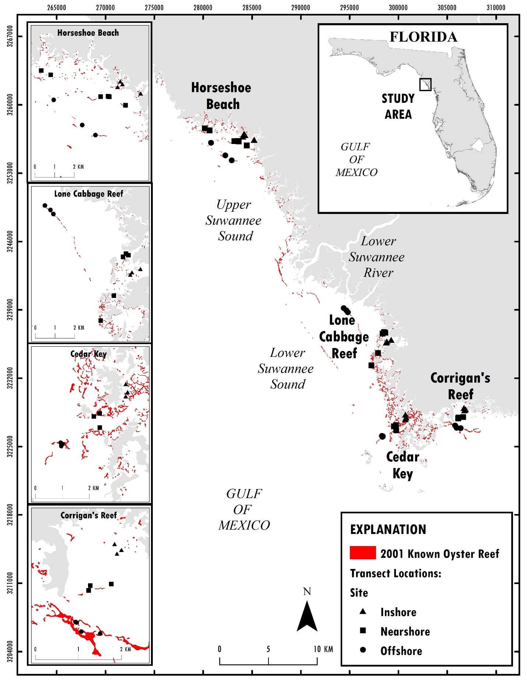

Figure 1. Map of the study area, showing locations of sampling sites within localities of major oyster reef complexes. Within each locality, note that transects were placed on reefs representing a gradient from inshore to offshore. Especially at offshore reefs, note the coastwise orientation and linearity of reefs.



Figure 2. Histogram of density (y-axis, oysters/m2) of live oysters counted (x-axis) on intertidal reefs in the Big Bend of Florida. The red line represents the predicted density of oyster counts if these data follow a negative binomial distribution.

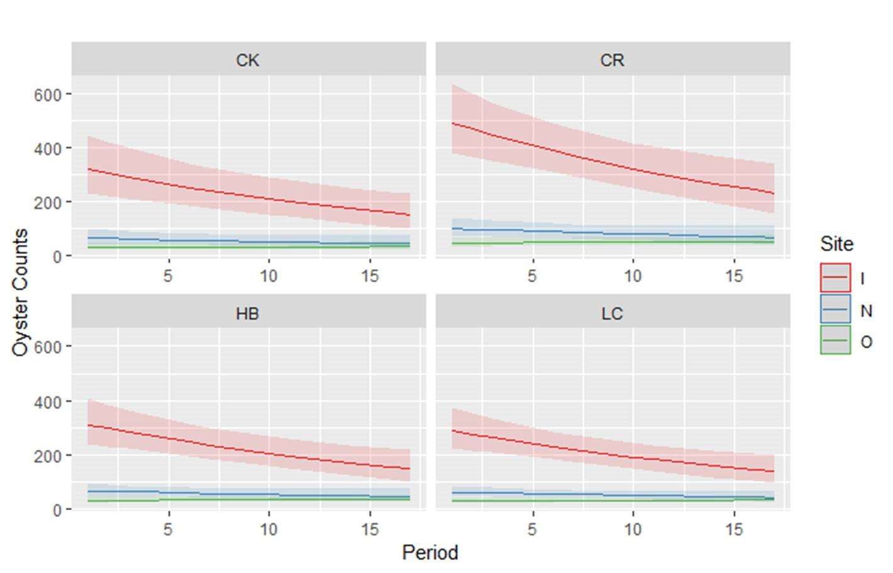

Figure 3. Predicted oyster counts using the best-fit negative binomial model offset by transect length from each locality CK = Cedar Key, CR = Corrigan’s reef, HB = Horseshoe Beach, and LC = Lone Cabbage based on data from 2010-2019. Colored lines represent Inshore (red), Nearshore (blue), and Offshore (green) sites within each locality. Shaded regions represent 95% CI on the predicted values.



Figure 4. Mean daily discharge by year and associated variance and CV of daily discharge and total annual discharge (CF/S by convention) for the Suwannee River measured at USGS Wilcox gauge from October 1941 to July 2019. Red LOWESS smoothing line provided to show general trends in discharge. Blue dashed line is the average mean daily discharge, variance, CV, or total annual discharge from 1941-2019.



Figure 5. Mean daily discharge by year and associated variance and CV of daily discharge and total annual discharge (CF/S by convention) for the Suwannee River measured at USGS Wilcox gauge from January 2010 to July 2019. Red LOWESS smoothing line provided to show general trends in discharge. Blue dashed line is the average mean daily discharge, variance, CV, or total annual discharge from 1941-2019.

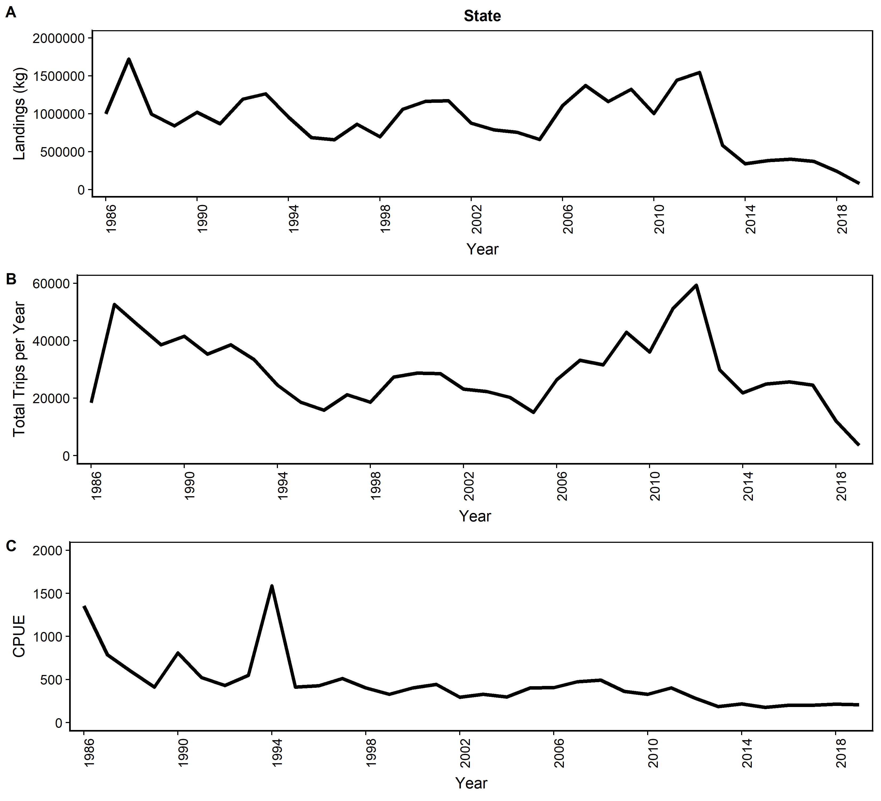

Figure 6. Oyster landings (whole meat weight, panel A), oyster fishing trips (panel B), and oyster catch per trip (CPUE, panel C) for the state of Florida from 1986-July 2019. Data for 2018 and 2019 are provisional.

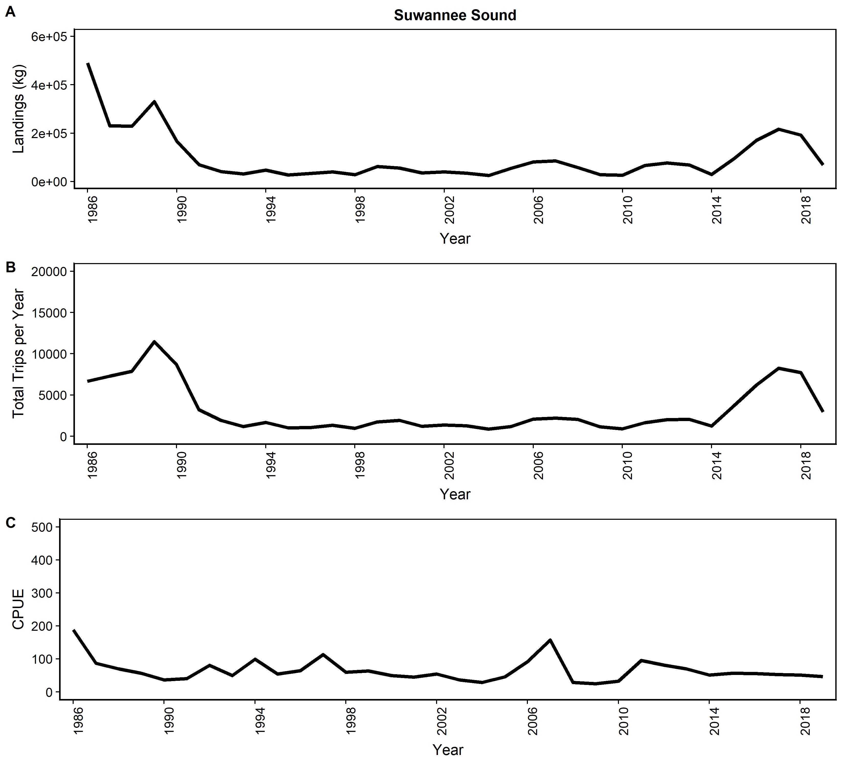

Figure 7. Oyster landings (whole meat weight, panel A), oyster fishing trips (panel B), and oyster catch per trip (CPUE, panel C) for Suwannee Sound, Florida (Levy, Dixie, Taylor counties) from 1986-July 2019. Data for 2018 and 2019 are provisional.

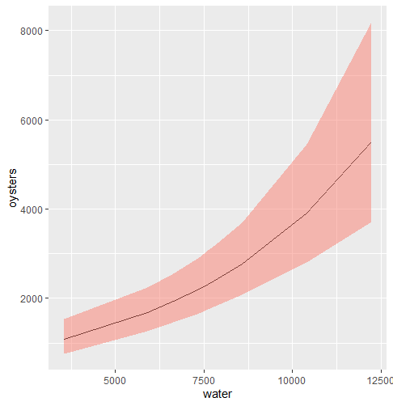

Figure 8. Predicted oyster counts using the best-fit negative binomial model offset by transect length including mean annual discharge with a 1-year lag as a covariate. Shaded regions represent 95% CI on the predicted values.

*Supplemental figures*

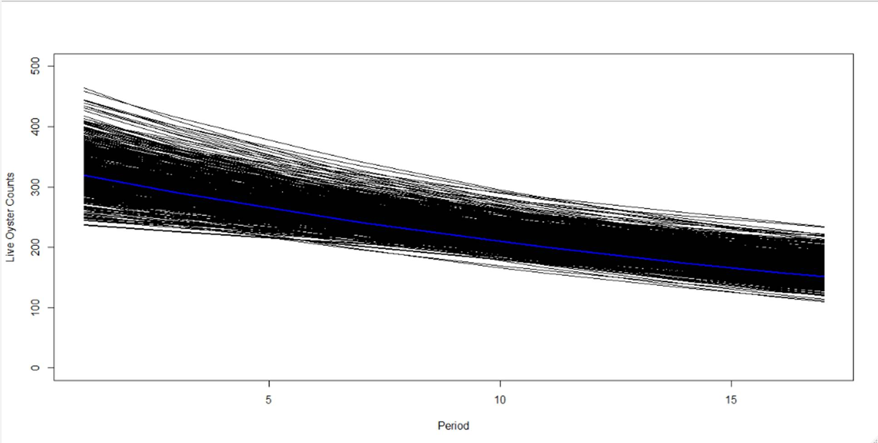

Figure S1. Predicted oyster counts using the best-fit negative binomial model offset by transect length (oyster counts = period * site + locality + offset(log(transect length))) fit to 1000 simulated data sets (black lines) for all localities combined based on data from 2010-2019. Solid blue line are predicted values fit to observed (actual) field data.

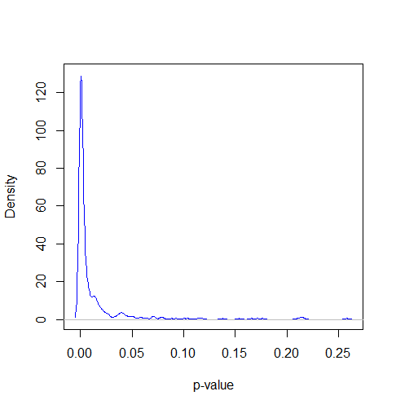

Figure S2. Kernel density plot (y-axis) and p-value (x-axis) for the “period” beta term fit to the model oyster counts = period * site + locality + offset(log(transect length)) from 1000 simulated datasets.

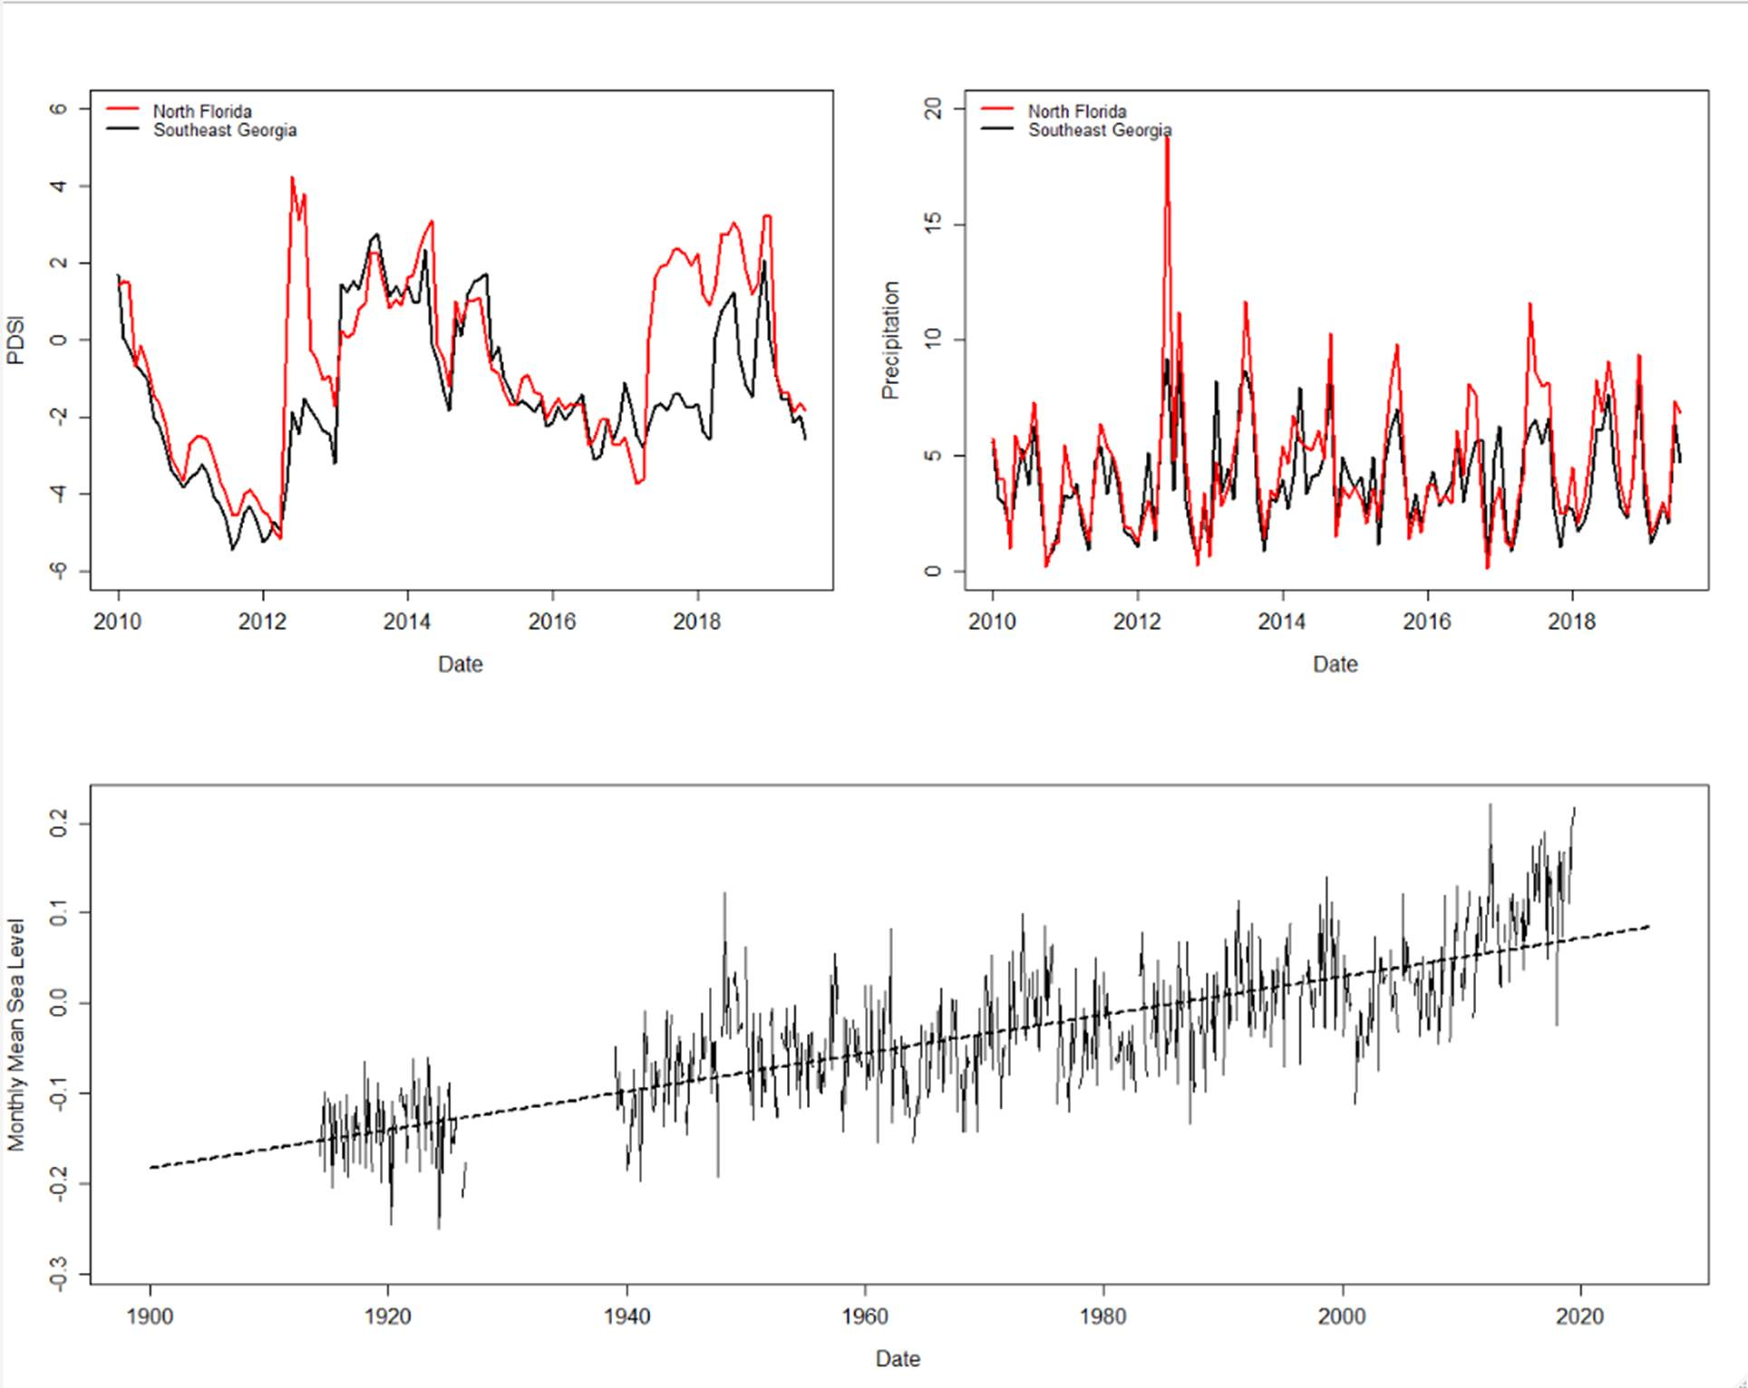

Figure S3. Panel A: Monthly Palmer drought severity index (y-axis) for north Florida (red line) and southeast Georgia (black line) by year (x-axis). Negative values indicate periods of drought and positive values periods of higher soil moisture. Data from https://tinyurl.com/y34ekmga. Panel B: Precipitation index that I need to think about some more. Panel C: Monthly mean sea level (y-axis, solid black line) over year (x-axis) from NOAA station 8727520, Cedar Key, Florida with a linear model (dotted black line) plotted for reference. Average seasonal cycle removed by NOAA. Data from https://tinyurl.com/yxqgtd32.